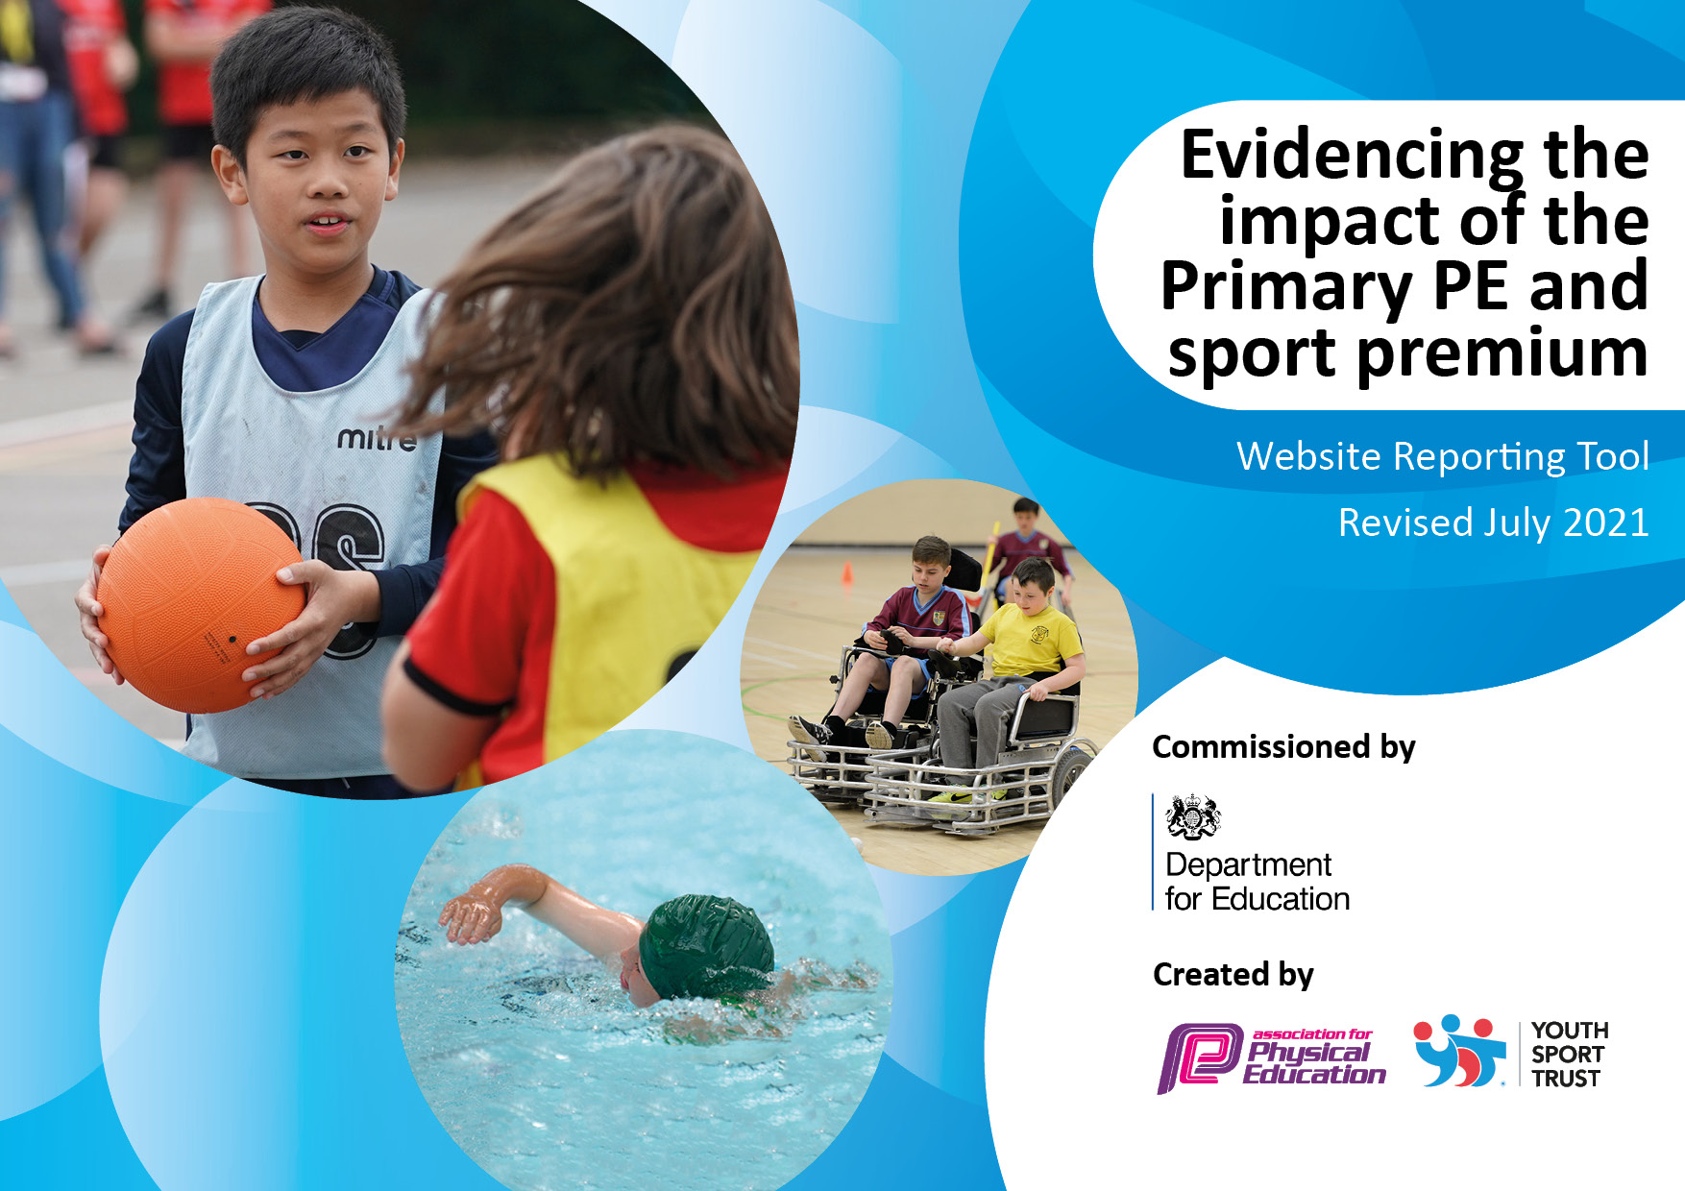
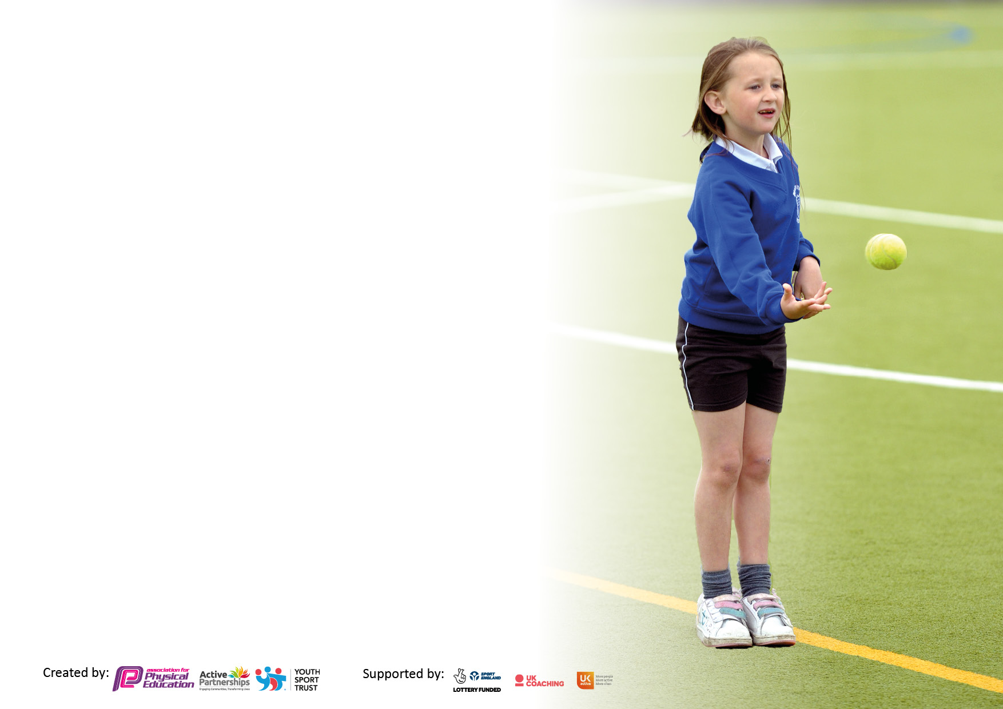

It is important that your grant is used effectively and based on school need. The Education Inspection Framework makes clear there will be a focus on ‘whether leaders and those responsible for governors all understand their respective roles and perform these in a way that enhances the effectiveness of the school’.

Under the Quality of Education Ofsted inspectors consider:
Intent - Curriculum design, coverage and appropriateness
Implementation - Curriculum delivery, Teaching (pedagogy) and Assessment
Impact - Attainment and progress

To assist schools with common transferable language this template has been developed to utilise the same three headings which should make your plans easily transferable between working documents.

Schools must use the funding to make additional and sustainable improvements to the quality of Physical Education, School Sport and Physical Activity (PESSPA) they offer. This means that you should use the Primary PE and sport premium to:

- Develop or add to the PESSPA activities that your school already offer
- Build capacity and capability within the school to ensure that improvements made now will benefit pupils joining the school in future years
- The Primary PE and sport premium should not be used to fund capital spend projects; the school’s budget should fund these.

Pleasevisitgov.ukfortherevisedDfEguidanceincludingthe5keyindicatorsacrosswhichschoolsshoulddemonstrate animprovement.Thisdocumentwillhelpyoutoreviewyourprovisionandtoreportyourspend.DfEencouragesschools to use this template as an effective way of meeting the reporting requirements of the Primary PE and sport premium.

We recommend you start by reflecting on the impact of current provision and reviewing the previous spend.

Schools are required to publish details of how they spend this funding, including any under-spend from 2019/2020, as well as on the impact it has on pupils’ PE and sport participation and attainment. All funding must be spent by 31st July 2022.

We recommend regularly updating the table and publishing it on your website throughout the year. This evidences your ongoing self-evaluation of how you are using the funding to secure maximum, sustainable impact. Final copy must be posted on your website by the end of the academic year and no later than the 31st July 2021. To see an example of how to complete the table please click HERE.
Created by: Supported by:

Details with regard to funding
Please complete the table below.

Total amount carried over from 2021/22 | £1,452 overspend
Total amount allocated for 2022/23 | £17,328
How much (if any) do you intend to carry over from this total fund into 2023/24? | £875 overspend
Total amount allocated for 2023/24 | £18,790 PE and Sports Premium Grant
Total amount of funding for 2023/24. To be spent and reported on by 31st July 2024. | £17,915
Swimming Data
Please report on your Swimming Data below.

Meeting national curriculum requirements for swimming and water safety.  N.B. Complete this section to your best ability. For example you might have practised safe self-rescue techniques on dry land which you can then transfer to the pool when school swimming restarts.  Due to exceptional circumstances priority should be given to ensuring that pupils can perform safe self rescue even if they do not fully meet the first two requirements of the NC programme of study | Year 5 and 6 were provided with swimming instruction as a top up. All pupils were assessed.  A heated pool was hired on site at school for 3 weeks along with swimming instructors for this purpose.  Year 3 pupils completed swimming lessons at the local pool.
What percentage of your current Year 6 cohort swim competently, confidently and proficiently over a distance of at least 25 metres?  N.B. Even though your pupils may swim in another year please report on their attainment on leaving primary school at the end of the summer term 2023.  Please see note above | 89%
What percentage of your current Year 6 cohort use a range of strokes effectively [for example, front crawl, backstroke and breaststroke]?  Please see note above | 89%
What percentage of your current Year 6 cohort perform safe self-rescue in different water-based situations? | 89%
Schools can choose to use the Primary PE and sport premium to provide additional provision for swimming but this must be for activity over and above the national curriculum requirements. Have you used it in this way? | Yes – see above comment and costings in KI 4

Action Plan and Budget Tracking
Capture your intended annual spend against the 5 key indicators. Clarify the success criteria and evidence of impact that you intend to measure to evaluate for pupils today and for the future.

Academic Year: 2022/23 | Total fund allocated: £17,328 | Date Updated: 25/07/2023
Key indicator 1: The engagement of all pupils in regular physical activity – Chief Medical Officers guidelines recommend that primary school pupils undertake at least 30 minutes of physical activity a day in school |  |  |  | Percentage of total allocation:
 |  |  |  | 53.5%
Intent | Implementation |  | Impact
Your school focus should be clear what you want the pupils to know and be able to do and about  what they need to learn and to  consolidate through practice: | Make sure your actions to achieve are linked to your intentions: | Funding allocated: £9270 | Evidence of impact: what do pupils now know and what can they now do? What has changed? | Sustainability and suggested next steps:
- To continue to develop the use of the outdoor area – in particular for Key Stage One, looking at transition from EYFS to KS1  - For the children to be engaged in regular and varied physical activity (including after school competitions) and to understand why physical activity is important. | - Equipment purchased to provide a variety of activities during the school day  - VRSS Partnership provided a range of activities for children to engage with, including cricket and baton relay with other local schools.  - Sports Apprentice provided physical activity during morning session before school started.  - Balance Bikes sessions for EYFS | £2436 (equipment)  £3397 (Vale Royal Sports Partnership and School Sports Services)  £2737 (Sports Apprentice)  £700 | - Children have further developed their understanding of the importance of regular physical activities  - Children have developed an awareness of a wider range of activities – e.g. archery  - Sports Apprentice has continued to raise the profile of physical activity during the school day  - EYFS children have gained confidence using the balance bikes rather than the trikes / scooters previously used. | - To look at a professional company delivering Forest Schools to children.  - To use Sports Coaches to deliver PE in school  - To use Sports Coaches to provide lunchtime clubs to increase physical activity at lunchtime
Key indicator 2: The profile of PESSPA being raised across the school as a tool for whole school improvement |  |  |  | Percentage of total allocation:
 |  |  |  | 4.6%
Intent | Implementation |  | Impact
Your school focus should be clear what you want the pupils to know and be able to do and about  what they need to learn and to  consolidate through practice: | Make sure your actions to achieve are linked to your intentions: | Funding allocated:  £796 | Evidence of impact: what do pupils now know and what can they now do? What has changed? | Sustainability and suggested next steps:
- To have a whole school focus on developing a range of clubs for children in the next academic year.  - Engage parents to help with coaching – football and netball.  - Develop a girl’s football team – Ks2 girls had a talk from a professional female footballer in the summer term.  - New kit purchased for pupils to wear at competitions | - A wide variety of clubs were offered during the course of the year all at nil cost  - Parents supported netball club.  - Girls football team still needs to be developed | £0  £0  - £796 | - Surveys show that parents appreciate the clubs that have been offered  - Pupils benefitted from coaching  - Pupils describe sense of pride in wearing kit | - Consider using sports coaches to provide clubs afters school so that a greater range of clubs can be offered including those for younger children  - Sports Apprentice to offer clubs after school  - To have a whole school focus on developing a wider range of clubs for the children in the next academic year, including younger children

Key indicator 3: Increased confidence, knowledge and skills of all staff in teaching PE and sport |  |  |  | Percentage of total allocation:
 |  |  |  | 15.8%
Intent | Implementation |  | Impact
Your school focus should be clear | Make sure your actions to | Funding | Evidence of impact: what do | Sustainability and suggested
what you want the pupils to know | achieve are linked to your | allocated: £2737 | pupils now know and what | next steps:
and be able to do and about | intentions: |  | can they now do? What has
what they need to learn and to |  |  | changed?
consolidate through practice:
- Sports Apprentice to provide clubs next year in order to further enhance provision | - Sports Apprentice used to help deliver clubs and attend competitions | £2737 | - Greater range of clubs were offered, and more competitions attended | Sports Coaches to be used to deliver PE (teachers to be present for CPD)
Key indicator 4: Broader experience of a range of sports and activities offered to all pupils |  |  |  | Percentage of total allocation:
 |  |  |  | 28.3%
Intent | Implementation |  | Impact
Your school focus should be clear | Make sure your actions to | Funding | Evidence of impact: what do | Sustainability and suggested
what you want the pupils to know | achieve are linked to your | allocated: £4900 | pupils now know and what | next steps:
and be able to do and about | intentions: |  | can they now do? What has
what they need to learn and to |  |  | changed?:
consolidate through practice:
- To provide small group swimming lessons to Year 5 and 6  - Year 6 children took part in a community event – Crown Green Bowling. | - A heated, pop up pool was provided on site for 3 weeks with instructors | £4900  £0 | - Children report enjoying lessons and those children who lacked confidence reported that the on-site pool, the small groups and the instructors really helped them to gain water confidence  - Parent feedback via Parent Council and Parent surveys was excellent.  - Children enjoyed playing with members of the community at the local bowling club. | - Repeat bowling experience on an annual basis.  - Consider using pool again after reviewing costs  - Offer a wider range of clubs through Sports Coaches – Try Something New

Key indicator 5: Increased participation in competitive sport |  |  |  | Percentage of total allocation:
 |  |  |  | 2.9%
Intent | Implementation |  | Impact
Your school focus should be clear | Make sure your actions to | Funding | Evidence of impact: what do | Sustainability and suggested
what you want the pupils to know | achieve are linked to your | allocated: | pupils now know and what | next steps:
and be able to do and about | intentions: | £500 | can they now do? What has
what they need to learn and to |  |  | changed?:
consolidate through practice:
- To further develop participation in competitive sport in the next academic year by using the Sports Apprentice to accompany children to events  - To further develop community links | - The sports apprentice was used to accompany children to sports competitions  - Community groups approached school and it was agreed that the school field could be used | £500  £0 | - Children have begun to take part in more competitions  - Strengthened links with community clubs | - Continue to develop participation in competitive sports. Look at refining selection process to engage more children.  - Develop more teams and take part in more competitions, including a girls football team.

Signed off by
Head Teacher: | Joanne Hyslop
Date: | 25 July 2023
Subject Leader: | Michelle Oakes
Date: | 25 July 2023
Governor: | Martin Mewies
Date: | 25 July 2023

