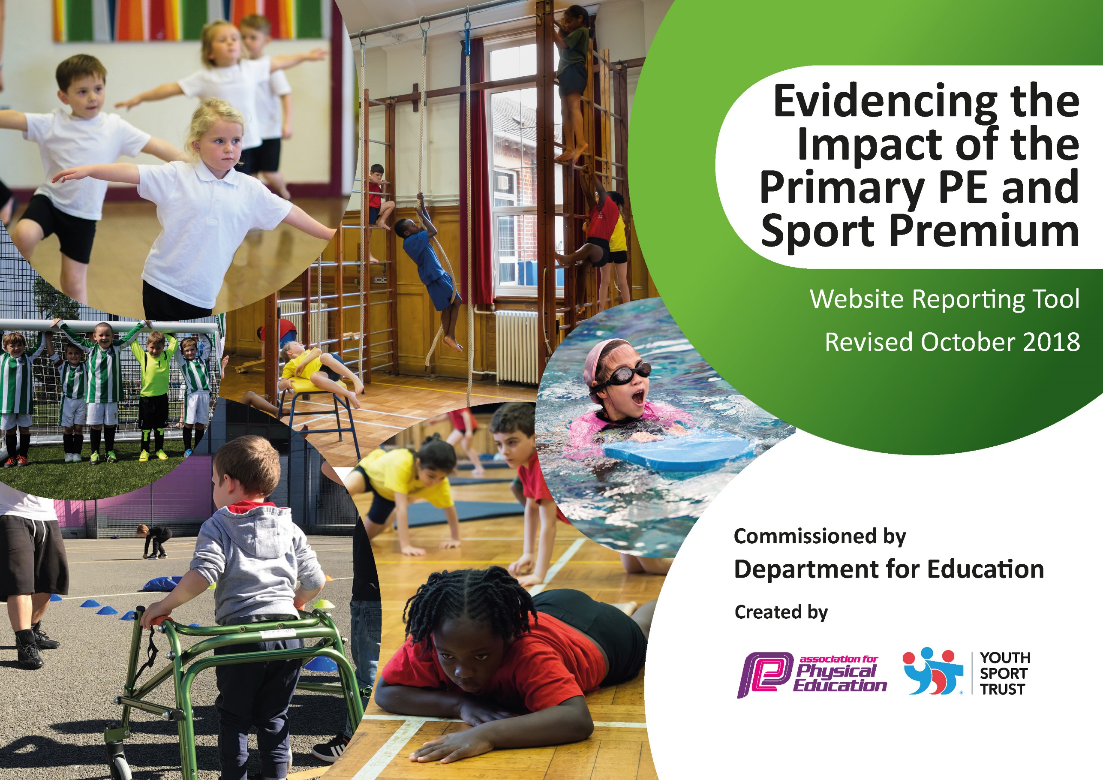
Support for review and reflection - considering the 5 key indicators from DfE, what development needs are a priority for your setting and your students now and why? Use the space below to reflect on previous spend, identify current need and priorities for the future.

Key achievements to date: | Areas for further improvement and baseline evidence of need:
- Providing 2 hours of PE per week for all pupils  - Upskilling staff in PE  - PE Pupil Progress Tracker modified  - Providing Active Breaks and Lunchtimes lead by pupils & staff  - Introduction of 5-a-day  - Introduction of Daily Mile  - Celebration of sporting achievements (Notice board, Family service, website, Newsletter)  - Tracking documents to highlight sporting participation (Competitive events, Festivals, Target groups, Extracurricular Clubs) | - Introduction of Active Breakfast clubs  - Provide a wider range of Active After-school clubs  - More pupils to experience Representing the school at Sporting Fixtures  - Staff to continue to work alongside & plan with PE Mentor  - Reward pupils for outstanding Sporting Values  - Sporting Challenges to increase engagement of physical activity during the day

Meeting national curriculum requirements for swimming and water safety | Please complete all of the below:
What percentage of your current Year 6 cohort swim competently, confidently and proficiently over a distance of at least 25 metres?  N.B. Even though your children may swim in another year please report on their attainment on leaving  primary school. | Aprox 97%
What percentage of your current Year 6 cohort use a range of strokes effectively [for example, front crawl, backstroke and breaststroke]? | Aprox 95%
What percentage of your current Year 6 cohort perform safe self-rescue in different water-based situations? | 100%
Schools can choose to use the Primary PE and Sport Premium to provide additional provision for swimming but this must be for activity over and above the national curriculum requirements. Have you used it in this way? | No

Action Plan and Budget Tracking
Capture your intended annual spend against the 5 key indicators. Clarify the success criteria and evidence of impact that you intend to measure to evaluate for students today and for the future.

Academic Year: 2018/19 | Total fund allocated: £18702  b/f overspend £2104  2018/19 spend £18163  Total spend £20265  c/f overspend £1563 |  |  | Date Updated: July 2019
Key indicator 1: The engagement of all pupils in regular physical activity – Chief Medical Officer guidelines recommend that primary school children undertake at least 30 minutes of physical activity a day in school |  |  |  |  |  |  |  | Percentage of total allocation:
 |  |  |  |  |  |  |  | %
School focus with clarity on intended impact on pupils: | Actions to achieve: |  |  | Funding allocated: |  |  | Evidence and impact: | Sustainability and suggested next steps:
- 5-a-day fitness  - Daily Mile  - Active Breaks  - Active Lunchtimes | - New equipment purchased for use at Lunchtimes (& to enhance PE lessons)  - Registration with VRSSP** -providing BB training, 5-a-day registration  - Break-time Buddies training provided by VRSSP**  - Line markings for active playtimes  - Play equipment (50% paid by FODS)  *Committed to before D of E ruling 25.10.18 |  |  | £1027.30  £2947.80 **  £4728  £7000 |  |  | - Pupils are now more engaged in lessons when given an “Active Break” eg 5-a-day  - Pupils stamina and all round fitness has increased from completing Daily Mile. This has resulted in pupils being more enthusiastic towards sport and sporting events.  *Parents have emailed to report on how enthusiastic their children are towards sport now. Some explaining how they have seen a physical change in their child because of the encouragement of taking part in sporting activities within school.  - Pupils now opting for and active lunch time break working with Break-time Buddies and using engaging equipment. | - Sporting Challenges to maintain Active Breaks and enthusiasm  - Maintain the use of Heatmaps to highlight areas of active development.  - Change the dynamics of Daily Mile to maintain enthusiasm eg skipping & linking with maths revision when working in Caterpillar teams.
Key indicator 2: The profile of PESSPA being raised across the school as a tool for whole school improvement |  |  |  |  |  |  |  | Percentage of total allocation:
 |  |  |  |  |  |  |  | %
School focus with clarity on intended impact on pupils: | Actions to achieve: |  |  | Funding allocated: |  | Evidence and impact: |  | Sustainability and suggested next steps:
- To increase the number of pupils Representing the school at sporting fixtures  - To highlight sporting achievements & celebrations  - To increase the variety of Extra curricular clubs | - To target specific groups to encourage and to give more children the opportunity to participate in sport  - Maintain reporting of sporting celebrations in school assemblies, school website and newsletters  - To give pupils the opportunity to experience a wide variety of sports through VRSSP competitions and Extra curricular clubs  SSS  Transport for Sports Week  Cover for Sports Week  - To encourage more children to take part in breakfast & afterschool sporting clubs with qualified coaches.  Employment of Qualified Coaches to deliver specific extra-curricular clubs |  |  | £631.20  £710  £160  £957 |  | Because of the amount of children we have engaged in sporting extra curricular clubs and the amount of children who have represented the school at sports competitions,  This year we have been awarded the GOLD SCHOOL GAMES MARK for the first time!  - We use tracking documents to highlight target groups and record pupils attending sporting events & extra-curricular sports clubs.  - We take part in a wide variety of competitive sports both within school and against other schools. By planning a range of intra-school competitions which can be accessed by all groups in school, selecting pupils and teams to take part in local inter-school competitions against other schools (both within the local cluster and across the Vale Royal School Sport Partnership), we aim to be fully involved in the School Games and other schools’ competitions  - Our school takes part in an annual School Games Festival which takes place to celebrate National School Sport Week. We engage with a wide-range of festivals and events which cater for many different children. We use this festival to give opportunities to those children in our target groups and to further develop our sports leaders and sportsmanship throughout the whole school.  Last year we took 50 pupils, this year we took over 130 pupils  - We annually apply for a School Games Mark award and strategically plan to develop our offer of competitive sport in line with the criteria (for example by involving a group of young people in the planning of our involvement in the School Games through our SSOC or by increasing the number of sporting events we enter) |  | - Pupils to complete questionnaire on current sporting activities outside of school and wish list of school based Extra Curricular clubs
Key indicator 3: Increased confidence, knowledge and skills of all staff in teaching PE and sport |  |  |  |  |  |  |  |  | Percentage of total allocation:
 |  |  |  |  |  |  |  |  | %
School focus with clarity on intended  impact on pupils: |  | Actions to achieve: | Funding  allocated: |  | Evidence and impact: |  |  |  | Sustainability and suggested  next steps:
- Staff to attend training where required. Training provided by Davenham staff & external specialists via School sports partnership & other recognised agencies.  - Teachers to work alongside M Oakes where required  - Teachers to liaise with M Oakes for PE lesson planning where necessary  - R Lee to gain Level 1 swimming qualification |  | - Staff to feel more confident in the delivery of PE  - PE lessons to be more engaging for pupils  New PE equipment purchased for the use during PE lessons and to help staff to deliver more engaging lessons  - PE lessons to cover a variety of sports  - Staff to build up a bank of knowledge and lesson plans  - R Lee to support pupils in the delivery of school swimming lessons | % of £1027.30 |  | - Quality of sport during PE lessons increasing  - Pupils enthusiastic & engaged during PE lessons  - Pupils fitness and skill ability increasing  - Participation in Extra Curricular activities increasing
Key indicator 4: Broader experience of a range of sports and activities offered to all pupils |  |  |  |  |  |  |  |  | Percentage of total allocation:
 |  |  |  |  |  |  |  |  | %
School focus with clarity on intended  impact on pupils: |  | Actions to achieve: | Funding  allocated: |  | Evidence and impact: |  |  |  | Sustainability and suggested  next steps:
Additional achievements:  - Curriculum map for PE planned yearly  - More sporting events attended  - Breakfast & Afterschool clubs to be varied by term to offer a wide range of activities |  | - Staff to follow Curriculum map to ensure a variety of sports are covered during lessons  - Forward planning to enable more pupils to attend sporting events  - Links with sporting groups to encourage participation at Afterschool & Breakfast clubs  Via VRSSP | As indicators 1 & 2 |  | - Pupils are enthusiastic about PE lessons  - Pupils further develop personal sporting skills eg Leadership/Umpiring.  - Events organised by VRSSP |  |  |  | - Staff to look into incorporating different sports
Key indicator 5: Increased participation in competitive sport |  |  |  |  |  |  |  |  | Percentage of total allocation:
 |  |  |  |  |  |  |  |  | %
School focus with clarity on intended  impact on pupils: |  | Actions to achieve: | Funding  allocated: |  | Evidence and impact: |  |  |  | Sustainability and suggested  next steps:
- Forward planning to help with organisation when taking pupils to Competitive sporting events  - School questionnaire to find out which pupils participate in which sports outside of school & to what level  - Record maintained of pupils attendance of Sporting events  - Ensure pupils have access to correct kit, equipment and teaching/coaching |  | - Liaise with SSCo & Davenham Staff to provide support at events  - Questionnaire sent to all pupils  - Maintain tracking documents  - Regular maintenance of sports kit & equipment  - Contact sports specialists where necessary for support | As indicators 1 & 2 |  | As indicated in indicator 2  - Celebration of successes on Notice board, Newsletter, Website & Family Service  - Enthusiasm of pupils wanting to take part in events  - Records of events kept |  |  |  | - Extra training sessions for sports teams prior to event

