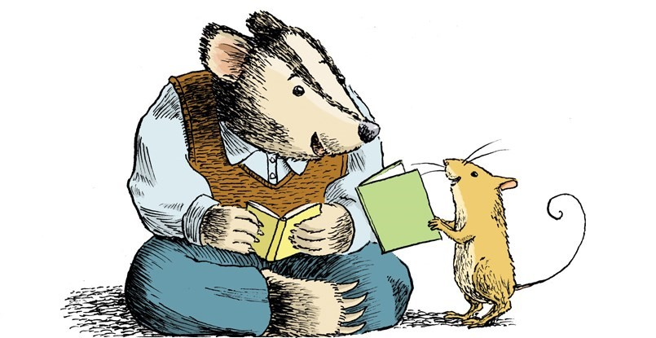

Learning to read does not happen all at once. It involves a series of stages that lead, over time, to independent reading and fluency.

A Beginning Reader
likes to look at books and enjoys listening to stories. They like to behave like a reader – holding books and pretending to read them, they begin to look at letter and words and play with them. They learn about words from songs, rhymes, signs and labels. They learns how text works – holding a book the right way up, starting at the front of a book, looking left to right in a book. They use pictures and memory to tell and retell a story

An Emerging Reader
learns that text is a common way to tell a story or share information. They begin to match written words to spoken words and recognise relationships between sounds and letters. They begin to experiment with reading, and are willing to try to say words out loud when reading simple texts. They find the pictures helpful in understanding the text, and learn that the words convey a message consistent with the pictures

An Early Reader
develops more confidence and uses a variety of methods, such as relying on visual cues, to identify words in texts. They are able to adapts their reading to different kinds of texts, they recognises many words, they know a lot about reading, and are willing to try new texts

A Fluent Reader
uses a variety of methods to identify words and their meanings. They can read various kinds of texts and predict events in a story. They can read with appropriate speed and expression and they relate the meaning of books to their own experience and knowledge.

It's natural to want to compare your child's reading abilities with those of other children of the same age, but not all children develop reading skills at the same pace. What's important is that you are aware of your child's reading level so that you can choose books and activities that will help him or her improve.

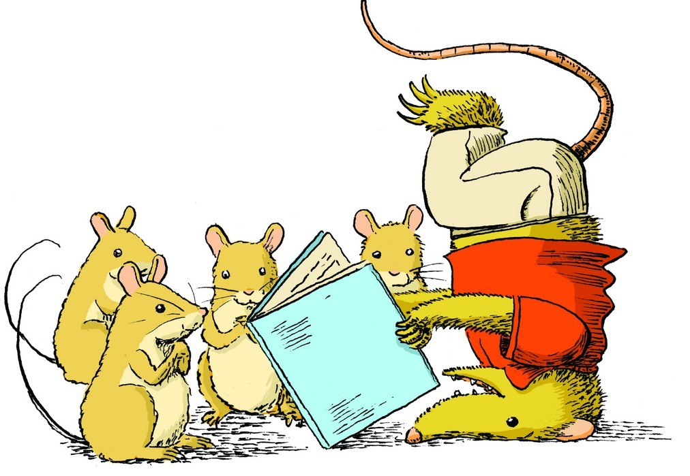
Top Tips to Help Your Child with Reading

Talk to Your Child
Here are some things you can do to help your child build an appreciation for words and language:
- Tell family stories.
- Talk to your child about things you are doing and thinking.
- Ask your child questions and encourage them to do the same.
- Encourage your child to tell you what he or she thinks or feels.
- Ask your child to tell you about his or her day.
- Be patient! Give your child time to find the words they want to use.
- Sing songs and recite nursery rhymes with your child.
- Play rhyming games.

Make Reading Fun
Reading aloud to children is the best way to get them interested in reading and can be lots of fun! Here are some ways to get the most out of reading to your young child:
- Read with drama and excitement! Use different voices for different characters in the story.
- Re-read your child's favourite stories as many times as your child wants to hear them, and choose books and authors that your child enjoys.
- Read stories that have repetitive parts and encourage your child to join in.
- Point to words as you read them. This will help your child make a connection between the words he or she hears you say and the words on the page.
- Read all kinds of material – stories, poems, information books and comics.
- Take your child to the library.
- Look at digital texts (http://www.oxfordowl.co.uk/)

Read Every Day
Children love routine, and reading is something that you and your child can look forward to every day. By taking the time to read with your child, you show him or her that reading is important.
- Try to read with your child as often as possible. It's the best thing you can do to help him or her learn at school!
- Set aside a special time each day when you can give your full attention to reading with your child. Choose a comfortable spot to read, where you can be close to your child.
- Share a variety of books.
- Read slowly so that your child can form a mental picture of what is happening in the story.
- Encourage your child to participate.
- Keep reading to your child even after he or she has learned to read. By reading stories that will interest your child but that are above his or her reading level, you can stretch your child's understanding and keep alive the magic of shared reading.

Set an Example
As a parent, you are your child's most important role model. If your child sees you reading, especially for pleasure or information, he or she will understand that reading is a worthwhile activity.
You can share many daily reading activities with your child. Here are some ideas:
- Read recipes, food labels, schedules, maps, instructions, and brochures.
- Read traffic signs and signs in stores and restaurants.
- Look up information in cookbooks, manuals, phone books, atlases, and dictionaries. Read greeting cards, letters, and e-mail messages to and from relatives and friends.

Talk About Books
Talking about the books you read is just as important as reading them. Discussing a story or a book with your child helps your child understand it and connect it to his or her own experience of life. It can also help enrich your child's vocabulary with new words and phrases.
Here are some ways to help your child acquire skills in comprehension, reasoning, and critical thinking:
- Ask your child about the kinds of books he or she would like to read.
- Talk to your child about your favourite books from childhood, and maybe read them.
- Encourage your child to ask questions and comment on the story and pictures in a book – before, during, and after reading it.
- Look at the cover and the title of a book with your child, and ask your child what he or she thinks might happen in the story.
- Encourage your child to think critically about the story. Does he or she agree or disagree with the author or what the characters do? Why?
- Think out loud about the story as you read, and encourage your child to do the same. For example, "I wonder why that happened?”.

Listen to Your Child Read
As your child learns to read, listen to him or her read aloud. Reading to you gives your child a chance to practise and to improve his or her reading skills.
As you listen to your child, remember that your reactions are important. Listen without interrupting but offer support when they get stuck. Try not to rush them or interrupt. Be enthusiastic and praise your child. If possible, be specific with your praise so that your child knows what he or she is doing well (“I really like how you re-read that when you realised it didn’t make sense.”)
- Show your child that you are enjoying the story by indicating interest and asking questions.
- Give your child time to figure out tricky words and reassure them that mistakes will help them learn.
- Try to have your child read aloud to you at times when there will be no interruptions.
- Make sure that your child selects books that aren't too difficult. Don't worry if the books your child chooses are a little easier at times this will build their confidence.
- Take turns reading with your child, especially if they are just beginning to read.
- Talk about a story after your child has read it, to make sure that they understand it.

Show that You Value Your Child's Efforts
Children learn to read over time, with lots of practice and support from parents and teachers.
Here are some ways you can show your child that you have confidence in his or her ability to learn:
- Be aware of your child's reading level to help you choose books and activities that are at the right level and that will help your child become confident.
- Be patient and flexible in your efforts to help your child.
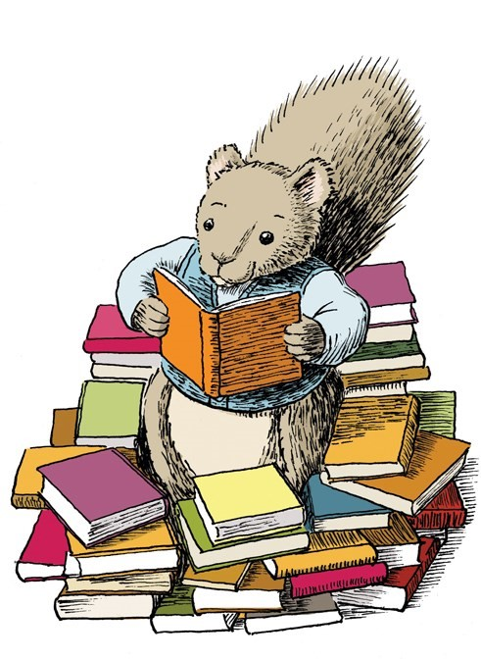
- Show your child that you see him or her as a growing reader, and praise his or her efforts to learn.

Stuck on a Tricky Word!
Try to encourage your child to use these strategies
- Think about what word would make sense in the story or sentence.
- Sound the word out.
- Think of a word that looks and sounds similar.
- Look for parts of the word that are familiar.
- Check the pictures and the punctuation marks for clues.
- Go back and read again.
- Ask for help with the word.
- Read past the word.

Where Can I Get Help?
When children see their parents and teachers working together, they feel more secure and confident. Staff at Davenham are always happy to offer support and help if you are finding reading with your child tricky, you have any worries or questions. Please come and have a chat.

