Multiplying and Dividing by 10, 100 and 1000

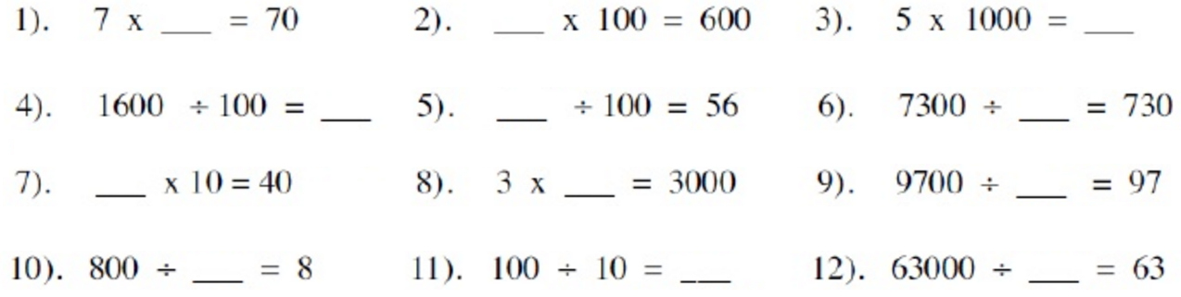

Division with Decimal Remainders:

